A000-Arc-Pipe-Lakota Sioux- Kicking Bear, Sioux, 1889

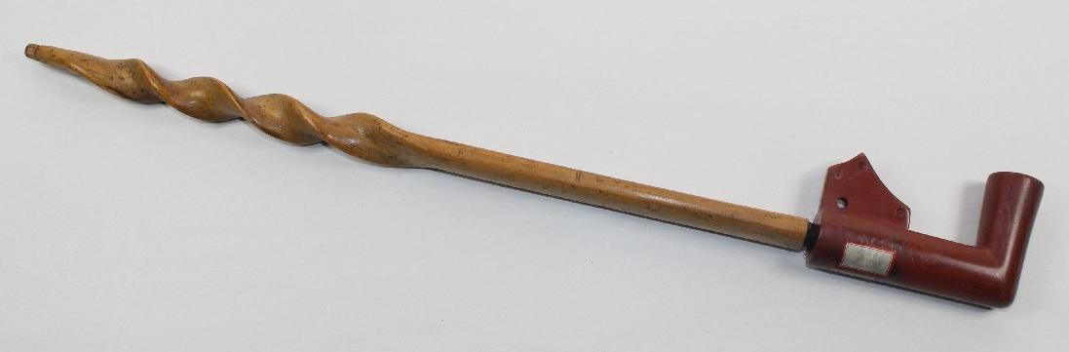

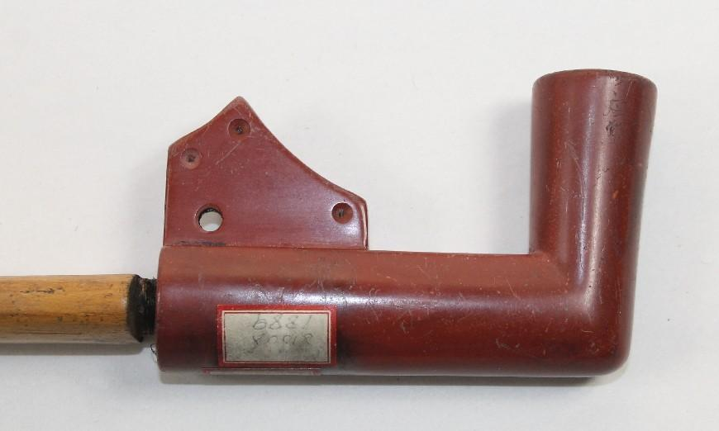

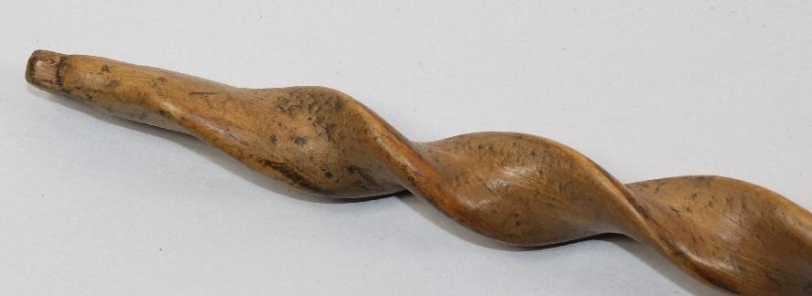 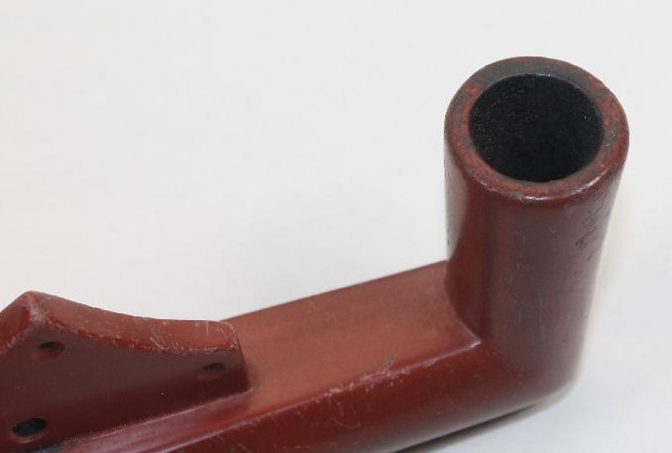

Matching pipe and stem. It measures 20" long overall. The stem is 16-1/2" long. It appears to be maple. The pipe is a Calumet Style. It has a drill hole for suspension in one spot. There are a couple old labels on the pipe. They read, Kicking Bear, Sioux, 1889. That is just what the labels read. The pipe is 4" long by 2-1/2" tall and well used and is 1-1/8" in thickness.

Case no.: 12

Accession Number:

Formal Label:

**Display Description:**

**LC Classification:**

Date or Time Horizon:

Geographical Area:

**Map:**

**GPS coordinates:**

Cultural Affiliation:

Media:

Dimensions:

Weight:

Condition:

Provenance:

**Discussion:**

**References:**